# Job Aid: Sync OneDrive with TysonOnline

All OneDrive users using sync to save a local copy of your OneDrive to your computer, will need to change the source of the sync after the migration is complete. Complete the steps below to sync your OneDrive to Tyson Online OneDrive. Please only complete these steps once the HuB migration is complete**. You must be logged into the** **Tyson HuB** **with your Tyson email address and password before syncing your OneDrive.**  Please reference the job aid on Login to the HuB on Tyson Online for support.

## OneDrive Sync Instructions

1. Select the OneDrive icon ( ) in the bottom right hand corner of your screen.

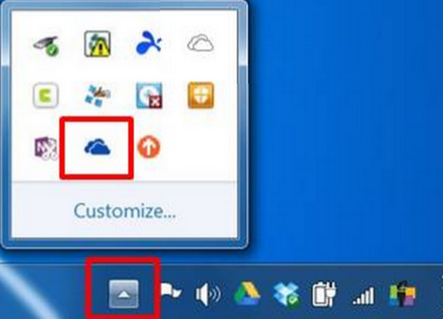

1

1. Right click on the icon and select **Stop syncing a folder…**

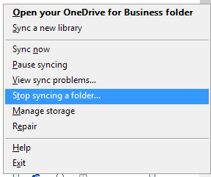

2

1. A pop-up window will ask you to confirm the stop sync action. Select **Yes.**

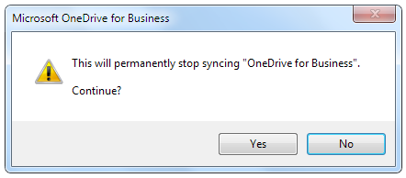

3

1. After confirming the stop sync action, a pop-up will display confirming that your OneDrive library is no longer synced with your PC. Click **OK.** This means that your local copies of files will not be updated to reflect changes that are made to files on the OneDrive cloud.

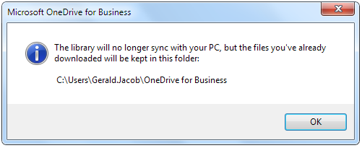

4

1. Navigate to your OneDrive icon and right click. On the menu, select **Sync a new library.**

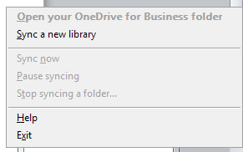

5

1. A pop-up will display showing that Microsoft OneDrive is contacting the server.

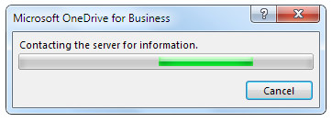

1. Once a connection to the server has been established, you will see a window asking if you are ready to sync your OneDrive. In this window, confirm the following information is correct:
   1. Tyson Online
   2. Your Tyson user name
   3. The location of your OneDrive files on your PC hard drive.

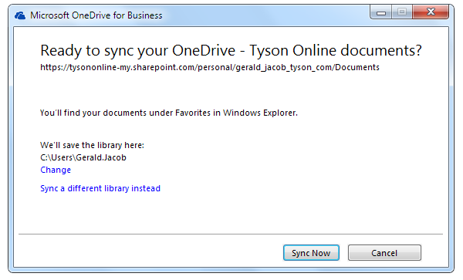

8

7c

User Name

7b

User Name

7a

1. If the above information is correct, select **Sync Now.**
2. The following window should be displayed letting you know that sync preparation is underway.

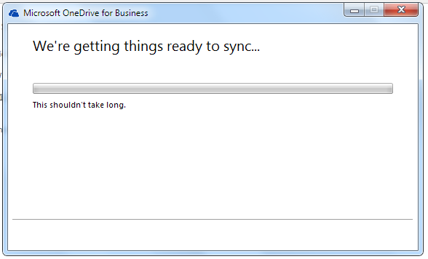

1. After the sync preparation is complete, the next window should confirm the sync is in progress. To view the progress of the sync, you can click **Show my files…**

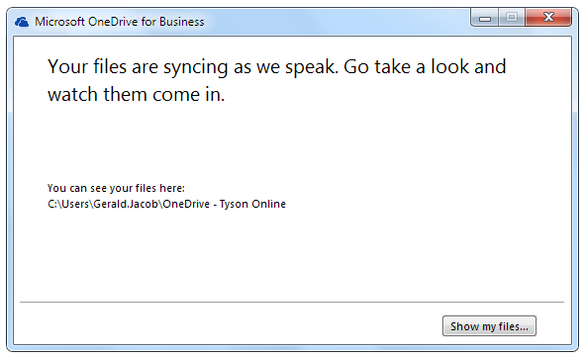

**User Name**

10

1. An explorer window should be displayed with a local copy of your OneDrive files. Note that after changing the sync source to TysonOnline, the local folder for your OneDrive content is titled **OneDrive – Tyson Online.**

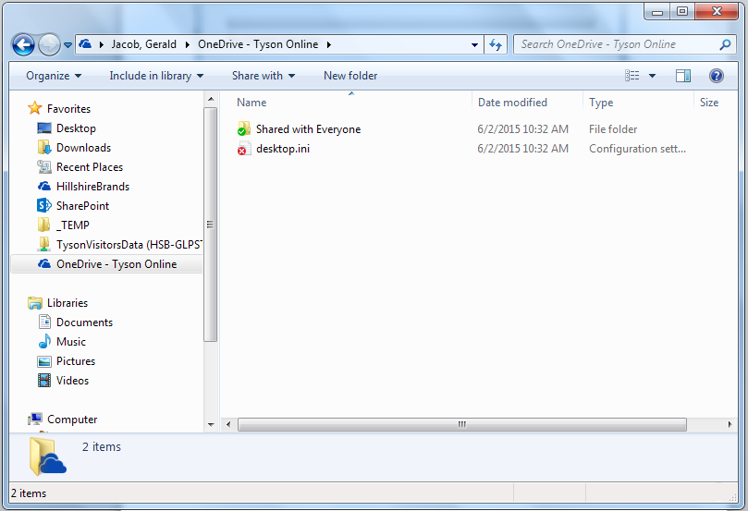

12

11

User Name

1. Your old OneDrive sync location is under Hillshire Brands. Once you have confirmed that all your content has been successfully migrated to TysonOnline OneDrive and synced to your PC, you can archive this folder or delete it altogether.

## Issue 1 – User is not logged into Tyson Online

If users are not logged into the HuB on TysonOnline, in step 7, users will see the following window. Users must be logged into the Tyson HuB with through Tyson email address and password in order for the sync location to auto-populate correctly.

The source of the OneDrive sync listed below is incorrect and should be listed as TysonOnline. In this case, users should select **Cancel.**

Users should refer to the job aid for logging into the Tyson Hub. The job aid will guide users through clearing their cookies, recovering login credentials, and logging into the HuB on TysonOnline.

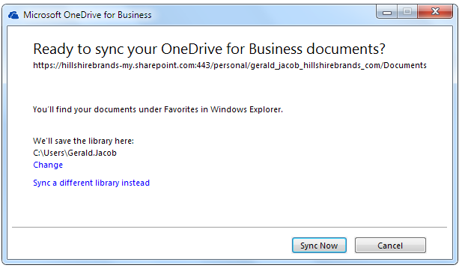

**Tysononline-my.sharepoint.com/personal……**